## Merchant Name: Pirros Implementation POC: Royce *(IM to fill)* CX POC: *[IMP to Add]*

### 

### 

| Notes Sections   *(AE to fill if they have, Implementation to be completion DRI on handoff)*   * Info on how merchant bills   - annual, some multi-year  - flat fee (commit to # of users)- mid-contract expansion for more seats - upfront - Their use of “pro-ration” under a seat-based model is not true pro-ration (as in usage-based), but rather reflects quarterly billing adjustments—this is not a concern.  Rev rec: they bill upfront for 2 skus , each sku has different rev rec schedules  200 customers, 20 inv/month, 2xing by EOY   Process: Pandadoc → hubspot → Ali create customer and invoices in Stripe → manual collection → manual cash app for non-Stripe payments  1) What is the merchant temperament?   Ari is really easy to work with and very straight forward  3) What are the Tabs features that the key POC cares about? |
| --- |

### Billing model *(Entire Section: Implementation to fill section)*

* Are there unique things about the customer creation process for this merchant?
* Information on how merchant bills
* How contract is broken up
* One off things to know about the merchant

### Contract Processing Steps *(Entire Section: Implementation/Success to fill Post-Go Live)*

1. Steps to process  
   Every BT in the Services Section should be a BT

* “Additional users” that are **unit** BT and any products mentioned under the “Additional Terms” section should not be processed as a BT
  + **However**, there may be flat fee items also called “additional users”. These **should** be processed
* Example:





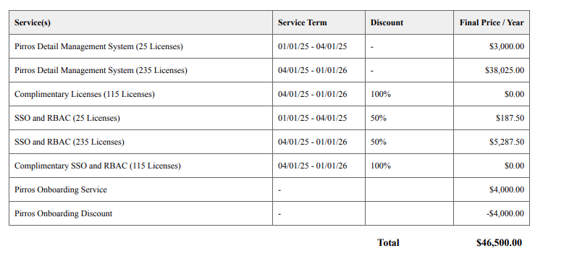

**Item Name:** Use the name exactly as listed in the "Service(s)" column of the Order Form.

**Quantity:** Use unit count that is explicitly stated; otherwise default to 1

* 1st line item in the example above:
  + Item Name: Pirros Detail Management System (25 Licenses)
  + Quantity: 25
  + Service Start Date: 1/1/25
  + Total months of Service: 3 (nearest whole month)
  + End Service Date: 3/31/25
  + Billing Type: Flat
  + Total Price: $3,000
  + Start Date: 1/1/25
  + Periods: 1
  + Frequency: 3 Months
* 2nd line item in the example above
  + Item Name: Pirros Detail Management System (235 Licenses)
  + Quantity: 235
  + Service Start Date: 4/1/25
  + Total months of Service: 9 (nearest whole month)
  + End Service Date: 12/31/25
  + Billing Type: Flat
  + Total Price: $38,025
  + Start Date: 1/1/25
  + Periods: 1
  + Frequency: 9 months

**Service Start Date:** Use the start date from the "Service Term" field. If not provided (e.g., onboarding services), default to the effective date of the Order Form.

**Total months of service:** nearest whole month that gets you to the end of the service term

* A lot of their annual contracts will say, for example, 1/1/25 - 1/1/26. This is incorrect, it should be 1/1/25 - 12/31/25 as they are one year contracts. **Do not** match until 1/1/26
  + Rev schedule for these will be start date noted in contract until end date noted in contract *minus* one day
* For one-time services/fees or implementation, default to 0 months of service

**Billing Type:** flat - please flag if you see anything different

**Total Price:** Use the "Final Price" amount listed in the Order Form

* Capture discounts in line unless listed as a separate line item e.g. for Pirros Onboarding Discount

**Billing Start Date & Payment Terms:**

Reference the Subscriptions & Payments Section

Example 1, same contract as the screenshot above:

- Effective date here is 1/1/25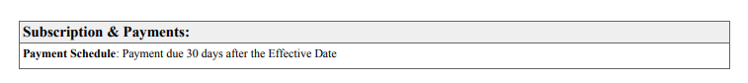

Example 2:

* This one goes off the service term

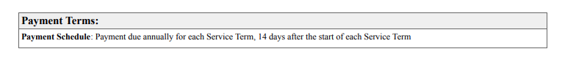

**Frequency:**

* Check payment terms
  + For subscriptions or recurring fees: use "Monthly" if billed monthly, "Annual" if invoiced annually, etc.
  + For onboarding, support, or one-time items: use None

**Net Terms:** Use any explicitly stated terms in the Payment Terms section (e.g., "Payment due 14 days after..."). If none are listed, default to 30 days.

**Integration Item:**

| **Product** | **Integration Item** |
| --- | --- |
| Pirros Additional Users | Pirros Detail Management Platform |
| Pirros Annual | Pirros Detail Management Platform |
| Pirros Base | Pirros Detail Management Platform |
| Pirros Database | Pirros Detail Management Platform |
| Pirros Detail Management | Pirros Detail Management Platform |
| Pirros Detail Management Platform | Pirros Detail Management Platform |
| Pirros Detail Management System | Pirros Detail Management Platform |
| Pirros Initial Seats | Pirros Detail Management Platform |
| Pirros Pilot | Pirros Detail Management Platform |
| Pirros User Accounts | Pirros Detail Management Platform |
| Pirros SAML SSO | SSO |
| Pirros SSO | SSO |
| SSO | SSO |
| SSO and RBAC | SSO |
| SSO, RBAC, and Workspaces | SSO |
| Family Management Add On |  |
| Pirros Onboarding Service | Pirros Onboarding Service |
| Discount | Discount |
| Complimentary Licenses | Discount |
| Workspaces | Workspaces |

**Example contracts:**

* E6cde37f-f94c-4043-a5e8-d09b0a26a5a9
* 71d427c0-7bf8-4f18-aa36-f1a0062c2428
* 966621d2-148f-4d9c-b786-da240a1e6720
* B9fb1786-25a3-47ed-b4b4-3e463ece1e26
* Baaee3a9-e8c6-4d22-847a-b8a465b600c6
* acd294da-750a-4d8c-8d65-45f33162b5a7

1. Anything to ignore in contracts?
2. Specifics processing things the merchant has requested that may differ by contract (e.g. always back-date invoice date to final day of the month)
3. Default Service Term
   1. If None Listed, Ops Default is 1 Year
4. Default Net Payment Terms
   1. If None, Ops Default is 0
5. Default Billing Frequency
   1. If None Listed, Ops Default is Monthly
6. How do we handle taxes as a line item?
   1. If None Listed, Ops Default is every tax line item becomes a BT

### Events Processing (if necessary) *(Entire Section: Implementation/Success to fill Post-Go Live)*

* Any important information on events billing

Integration Items Processing (if necessary)  
*(Entire Section: Implementation/Success to fill Post-Go Live)*

* What are the instructions for assigning integration items?
* Example: All Statsig integrations items should be labeled as “Sales”
* Example: All “Pinata” integration items should be labeled as “Software Subscription Bundle” unless otherwise noted by Merchant

Post Processing Communications (if necessary)  
*(Entire Section: Implementation/Success to fill Post-Go Live)*

* Does the Ops Team need to notify anyone on the team re: completion of processing batches in Implementation or Active phase?
* Who needs to be notified and when?
  + Example:
    - Who: Customer Success [Azmat Aziz] needs to be notified
    - Where: Messari internal merchant channel
    - When: contracts are processed [Merchant Phase: Active]

### Customer Information *(Entire Section: Implementation/Success to fill Post-Go Live)*

* Any important information on specifics customers of this merchant
  + Special memo’s certain invoices require
  + Invoice changes due to merchant/customer relationship

### Feature Requests *(AE to fill for all requests prior to Imp handoff, Imp to fill prior to go-live/Success to fill to fill Post-Go Live)*

* CARR reporting
  + Doing this manually today
  + Urgency: I said we are launching this soon but gave no timeline

### Merchant Calls *(AE to fill for all videos prior to Imp involvement, Imp to fill prior to go-live/Success to fill to fill Post-Go Live)*

* .Intro + part demo <https://us-56595.app.gong.io/call?id=4005712031574479431&account-id=6185788025012809606>
* .Demo <https://us-56595.app.gong.io/call?id=2800502320924420397&account-id=6185788025012809606>
* .Pricing + review of their contracts   
  <https://us-56595.app.gong.io/call?id=6586682561522924877&account-id=6185788025012809606>